**Balaji K- MongoDB – Assignment 1**

* **Exercise 1**

* **Exercise 2**

* **Exercise 3**

* **Exercise 4**

* **Exercise 5**

* **Exercise 6**

* **Exercise 7**

* **Exercise 8**

* **Exercise 9**

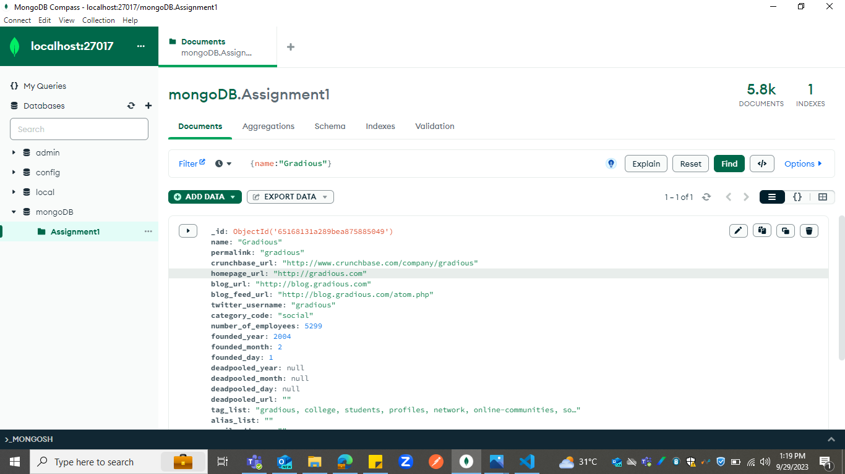

* **Exercise 10**

* **Exercise 11**

* **Exercise 12**

* **Exercise 13**

* **Exercise 14**

* **Exercise 15**

* **Exercise 16**

* **Exercise 17**

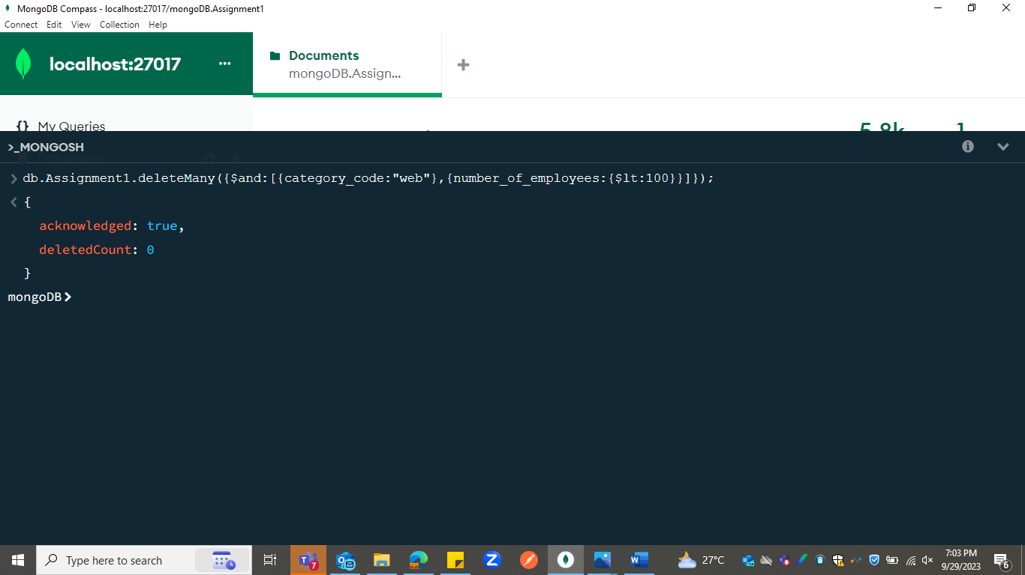

* **Exercise 18**

* **Exercise 19**

* **Exercise 20**

